Tutorial 7 - SPM (wk12 -done)

Question 1

Distributed Version Control
- Full local clone and offline commits
Each developer clones the entire repository to their machine, can commit locally without network access, and later push to the shared repository.
- Natural backup and easy integration flows
Because every clone is a complete copy, the project can be restored from developers’ machines if the server is corrupted.

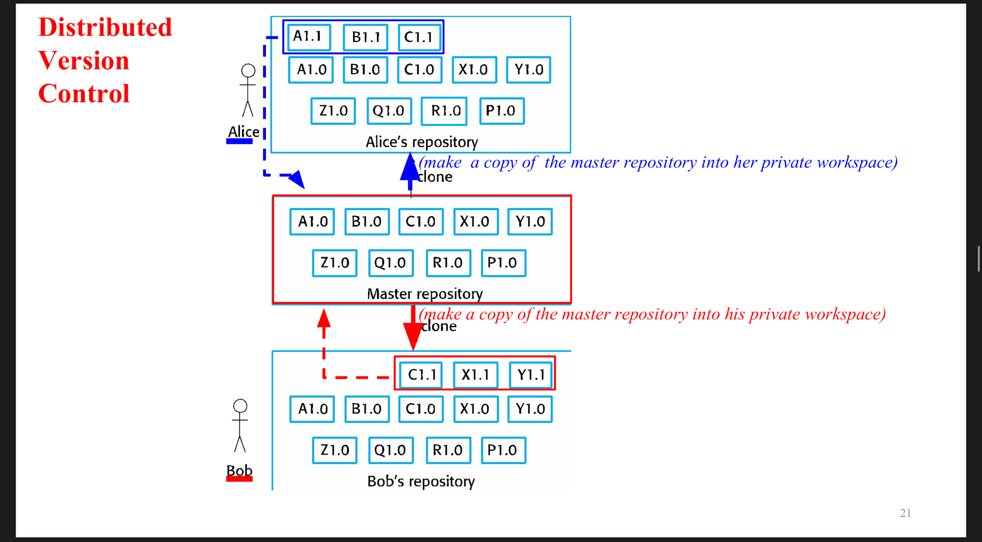
Centralized Version Control
- Single master repository with check-out/check-in workflow
There’s one authoritative repository, developers check out files, edit in a private workspace, and check in updates.
- Always-on network dependency and single point of control
Work typically depends on connectivity to the central server, which simplifies control but creates a single operational bottleneck/failure point compared with DVCS.

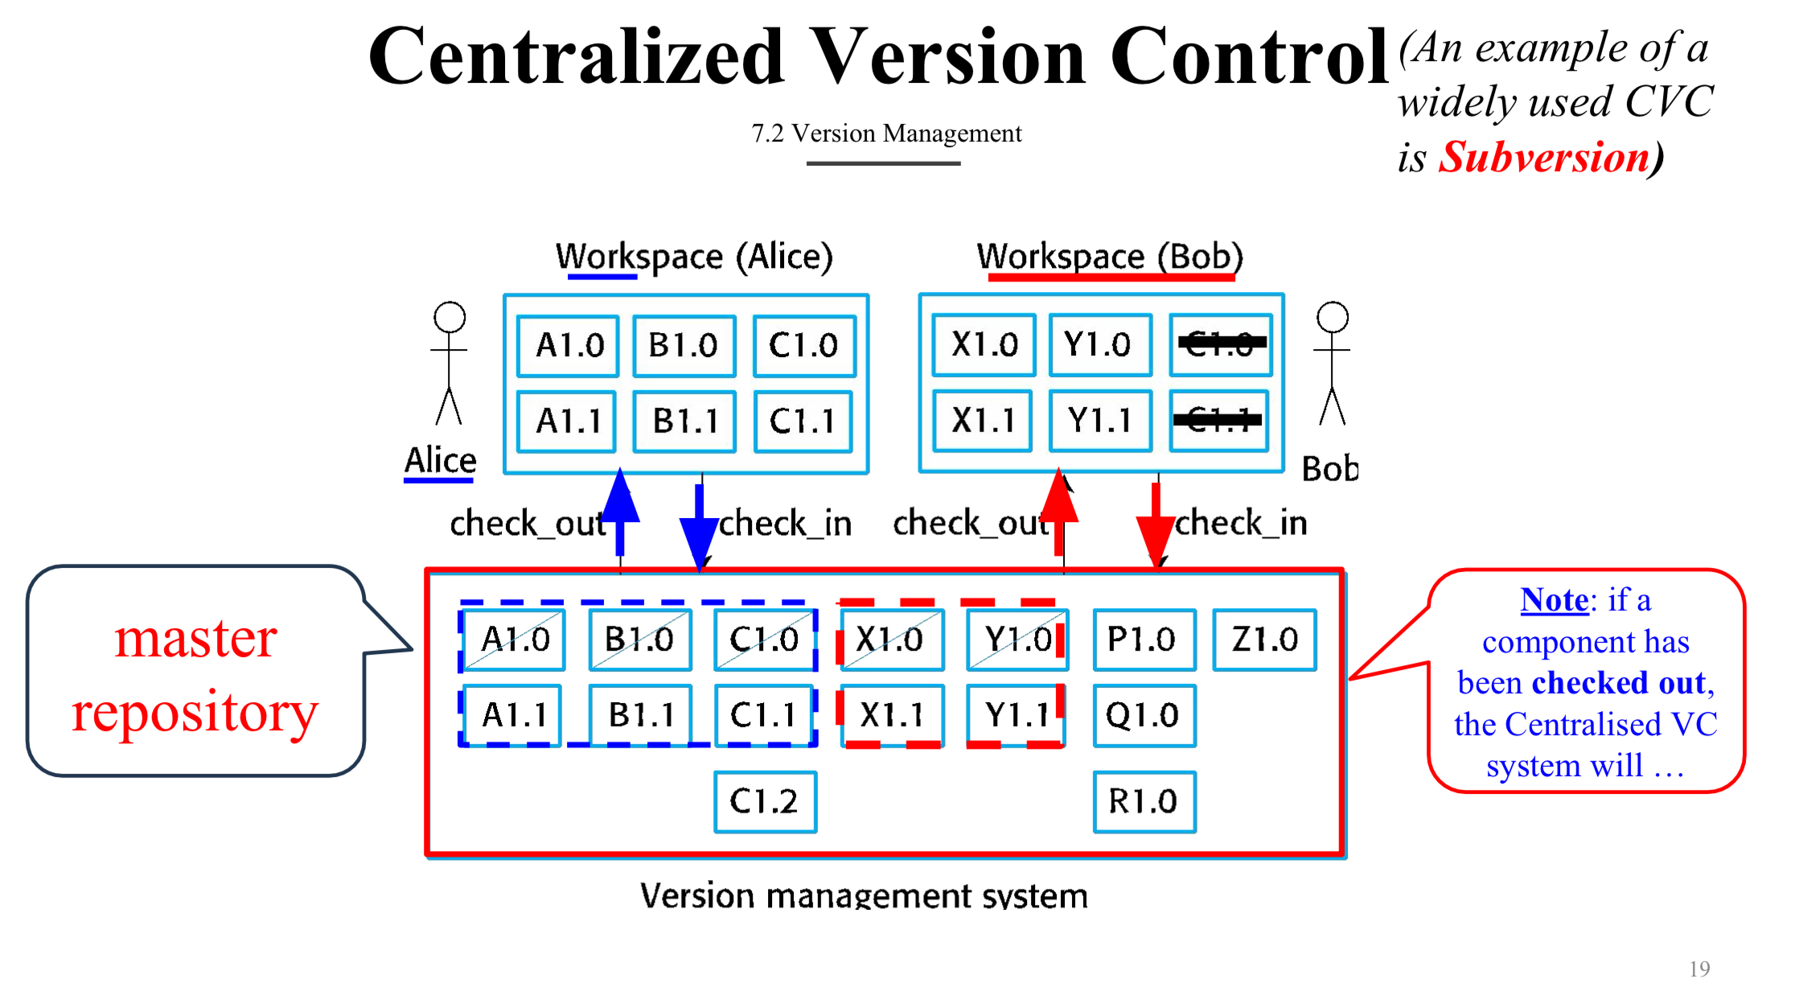
Question 2
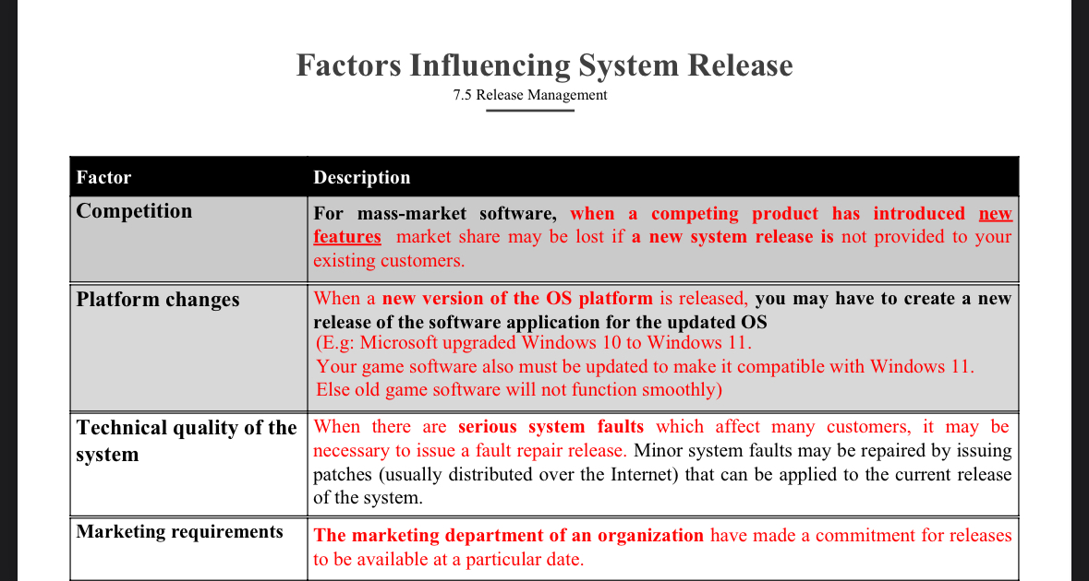

- Competition
  - If another company releases new features, our system also needs a new release.
  - Otherwise, we may lose customers because they will move to the competitor’s product.
- Platform changes
  - When a new version of an operating system (like Windows 11) is released, our software must also be updated.
  - If we don’t update, the old version may not work properly on the new OS.

Question 3
One of the change management activities is to approve the change requests from stakeholders. DiscussONE(1) factor in change analysis that influences whether the change request should be approved or not.

The benefits of the change
• The consequences of not making the change
• The costs of making the change
• The number of users affected by the change
• The product release cycle

